A REPORT OF SIX WEEKS INDUSTRIAL TRAINING

at

**TCIL-IT**

SUBMITTED IN PARTIAL FULFILLMENT OF THE REQUIREMENT FOR THE AWARD

OF THE DEGREE OF

**BACHELOR OF ENGINEERING**

Computer Science & Engineering



JUNE-JULY,2018

**SUBMITTED BY:**

**NAME : Ayush Sharma**

**UNIVERSITY UID :16BCS1550**

DEPARTMENT OF COMPUTER SCIENCE & ENGINEERING

CHANDIGARH UNIVERSITY, MOHALI

**CANDIDATE'S DECLARATION**

I **AYUSH SHARMA** hereby declare that I have undertaken six weeks industrial training at **TCIL-IT** during a period from **8th May** to **26th Jun** in partial fulfillment of requirements for the award of degree of B.E (COMPUTER SCIENCE & ENGINEERING) at CHANDIGARH UNIVERSITY GHARUAN, MOHALI. The work which is being presented in the training report submitted to Department of Computer Science & Engineering at CHANDIGARH UNIVERSITY GHARUAN, MOHALI is an authentic record of training work.

Signature of the Student

 The six weeks industrial training Viva–Voce Examination of__________________ has been held on ____________ and accepted.

 Signature of Internal Examiner Signature of External Examiner

**ABSTRACT**

* **E-cops Citizen Service** or police management system is a system which provides user a very easy access to the police crime investigation or crime solving system. In this project we provide a simple way to register or report a crime. This will very helpful in sensitive situation. In this project or system we can provide a platform to access police investigatory system. In this system we can report a crime and we can also know our status of reported crime. User will provide with a specific unique No. from which they can be aces their account.
* In this account all the information is present like name, complaint, officer which handled the case, progress of the case etc. Our main motive is to provide an easy accessible service to the citizen, so that they can directly interact with our investigation system.
* In this E-cops system we use XAMPP 3.2 server with php. Also HTML, CSS and Jscript is used for making this project. In this project we ensure more interactions between user and System. This application offer many services for user.

**ACKNOWLEDGEMENT**

*First and foremost, I would like to thank God. You have given me the power to believe in myself and pursue my dreams. I could never have done this without the faith I have in you, the Almighty.*

I would like to express my deep gratitude to “**TCIL-IT**” which gave me an opportunity to undergo 6 weeks industrial training at their prestigious organization. I am grateful to **Mr. Ramlal Sharma** for his valuable suggestions and directions throughout the development of the project. I am grateful for his cooperation during the period of my Project. Moral, intellectual and very frequently required support from all the faculty members is also hereby acknowledged.

I feel privileged being from an institution like **CHANDIGARH UNIVERSITY** which provide us their support during the entire period of training. I sincerely thankentire faculty of our department for their immense co-operation.

I would also like to thank my parents and my friends for their encouragement which greatly helped me in completing this project.

After doing this training I can confidently say that this experience has not only enriched me with technical knowledge but also has unparsed the maturity of thought and vision, the attributes required for being a successful professional.

**ABOUT THE COMPANY**



**Company profile**

TCIL-IT is managed by ICSIL (Intelligent Communication Systems India Ltd.), a Joint Venture of TCIL (Telecommunication Consultants India Ltd), a Govt. of India Enterprise and DSIIDC (Delhi State Industrial Infrastructure Development Corporation Ltd), a Govt. of Delhi Undertaking.   
TCIL has established its Training division TCIL- IT, which is running various courses duly approved by various Govt. departments for job oriented skill training. Keeping in view the rising need for quality skilled professionals, TCIL has introduced a gamut of comprehensive courses in Software, Hardware, Multimedia, Telecom & Mobile Phone technology, Interior Design, Fashion Technology, Health Safety and Environment, Engineering and management, Logistics, Call Centre management, through its nationwide network. Over the years TCIL has built up a solid reputation for offering world class advanced training in various sectors. From Indian Army, reputed Universities & Colleges, Banks, Govt. agencies & Multinational companies, TCIL -IT is being sought after by the biggest and the best for imparting job oriented skill training. The curriculum development team of TCIL-IT is in regular touch with today’s industry and updates the course curriculum regularly to meet its demands. As the course curriculum is designed giving equal importance to theoretical knowledge and practical skills, the students are sure to acquire relevant modern industries standards

**List of Figures**

|  |  |  |
| --- | --- | --- |
| **Figure No.** | **Title** | **Page No.** |
| 1. | PHP DEVELOPMENT DIAGRAM |  |
| 2. | DATA FLOW DIAGRAM |  |
| 3. | CONTEXT FLOW DAIGRAM | . |
| 4. | DFD VISITER, ADMINISTRATOR, USER | . |

# TABLE OF CONTENTS

***CERTIFICATE………………………………………..………………………..…...i***

***CANDIDATE’S DECLARATION……………………………………………….…ii***

***ABSTRACT…………………………...………………………………………….....iii***

***ACKNOWLEDGEMENT ……………………………………………...………......iv***

***ABOUT THE COMPANY……………………………………………………….….V***

***LIST OF FIGURES ………………………………………………………………..vi***

***LIST OF TABLES………………………………………………………..………...vii***

1. **INTRODUCTION…………………………..……........................................1-2**

1.1 PURPOSE OF PROJECT ………………………………..……………………..2

1. **TRAINING WORK & GENERAL DESCRIPTION …….........................3-5**

2.1 ABOUT PHP ……………………………….………..……………...................3

2.2 ABOUT HTML…………….…………………………………………..............4

2.3 ABOUT CSS …………………………………………………………………..4

2.4 ABOUT Jscript………………………………………………………………....4

2.5 ABOUT XAMPP……………………………………………………….………5

1. **PROJECT MODULES** **…………...…….…..…………….….......................6-8**

3.1 MODULES ……………………………………...…………………………....6-7

3.2 HARDWARE REQUIREMENT....................................................................7

3.3 SOFTWARE REQUIREMENT…………………………..………………....… .7.

3.4 FUNCTIONAL REQUIREMENTS & SPECIFICATIONS………………….....8

1. **SYSTEM DESIGN………..…………..……….…..……...............................9-19**
   1. DATABASE DESIGN ………………..……………...………………………...9
   2. PHP DEVELOPMENT DIAGRAM………………………………………..…10

4.3 DATA FLOW DIAGRAM.…….………..…………………..…………..……11-15

4.4 DATABASE TABLES STRUCTURE ……………………………….…….....16-19

1. **RESULT.……………………...………......…………………..………….….…20-31**
   1. PROJECT SNAPSHOT………………………………………………..……….20-31
2. **CONCLUSION……………………………………………………..…….…….32**

6.1 SCOPE OF PROJECT……………………………………………….………33

1. **REFRENCES...…………………………….....................................................34**

**CHAPTER -1**

**INTRODUCTION**

**E-cops Citizen Service** or police management system is a system which provides user a very easy access to the police crime investigation or crime solving system. In this project we provide a simple way to register or report a crime. This will very helpful in sensitive situation. In this project or system we can provide a platform to access police investigatory system. In this system we can report a crime and we can also know our status of reported crime. User will provide with a specific unique No. from which they can be aces their account.

In this account all the information is present like name, complaint, officer which handled the case, progress of the case etc. Our main motive is to provide an easy accessible service to the citizen, so that they can directly interact with our investigation system.

Recent years have seen an increasing use of computers within Police Forces, not just in general administration (e.g. payroll, personnel, e-mail, general office suites etc.), but also as a tool to assist the core business activity of policing (preventing and solving) crime. Increasing crime rates and the (greater awareness of modern criminals) puts a strain on existing methods and techniques. There is therefore a clear need for the application of advanced software technologies in order to make the best use of limited resources. The objective of this project is to provide an insight into the role software systems are playing in Police Forces.

The aim of proposed system is to develop a system of improved facilities. The proposed system can overcome all the limitations of the existing system. The system provides proper security and reduces the manual work. The existing system has several disadvantages and many more difficulties to work well. The proposed system tries to eliminate or reduce these difficulties up to some extent. The proposed system will help the user to reduce the workload and mental conflict. The proposed system helps the user to work user friendly and he can easily do his jobs without time lagging.

* 1. **PURPOSE OF PROJECT**

The main purpose of the project is to provide a very easy and user friendly access to the police investigatory system. Police investigatory system or police management system is a system which provides a very easy way to report a crime. In this project we provide user a service which directly connected to the police system. Also this can aware the peoples about their rights and law. A special portal for the women is also provides in this project. Our main purpose is providing an easy understanding and accessible police crime investigatory service. Main purpose to build this kind of project is to increase the speed of detecting and reporting a crime. It also show the step by step process of police and low and order about their investigation. It also gives a unique id for the police officers. It provides a list of all the police station near by your entered location.

The project titled as “E-COPS Citizen Service” is a web based application. This provides facility for reporting online crimes, complaints,. Any Number of clients can connect to the server. Each user first makes their login to sever to show their availability. The main purpose of the system is to provide a platform for user where they can interact with our Law and police directly. Where they can ensure their safety as well. The main modules in this project are :-

* Visitors
* Registered Users
* Administrator

**CHAPTER -2**

**TRAINING WORK & GENERAL DESCRIPTION**

In this section we can describe all the main languages and software with all their description. To build the E-cops system we use HTML and CSS for backend we use PHP Mysql and the software use is Xampp version 3.2.2. The brief description of different labels is given below:-

* 1. **ABOUT PHP**

PHP is an acronym for "PHP Hypertext Preprocessor". PHP is a widely-used, open source scripting language. PHP scripts are executed on the server.

**PHP** is a server side scripting language designed for web-development but also used as a general-purpose programming language. PHP is now installed on more than 244 million website and 2.1 million webserver.Originally created by Rasmus Lerdorf in 1995, the reference implementation of PHP is now produced by The PHP Group.While PHP originally stood for Personal Home Page,it now stands for PHP*:* Hypertext Pre-processor, a recursion acronym.

PHP code is interpreted by a web server with a PHP processor module, which generates the resulting web page: PHP commands can be embedded directly into an HTML source documents rather than calling an external file to process data. It has also evolved to include a command-line interface capability and can be used in standalone graphical applications.

PHP is free software released under the PHP license, which is incompatible with the GNU General Public License (GPL) due to restrictions on the usage of the term PHP.PHP can be deployed on most web servers and also as a standalone shell on almost every operating system and platform, free of charge.

* 1. **ABOUT HTML**

HTML stands for **H**yper **T**ext **M**arkup **L**anguage. HTML is a markuplanguage.A markup language is a set of markuptags**.** The tags describe document content.HTML documents containHTMLtags and plain text**.** HTML documents are also calledweb pages. HTML stands for Hyper Text Markup Language, which is the most widely used language on Web to develop web pages. HTML was created by Berners-Lee in late 1991 but "HTML 2.0" was the first standard HTML specification which was published in 1995. HTML 4.01 was a major version of HTML and it was published in late 1999. Though HTML 4.01 version is widely used but currently we are having HTML-5 version which is an extension to HTML 4.01, and this version was published in 2012.

* 1. **ABOUT CSS**

**CSS** stands for **C**ascading **S**tyle **S**heets. Styles define how to display HTML elements. Styles were added to HTML 4.0 to solve a problem. External Style Sheets can save a lot of work. External Style Sheets are stored in CSS files CSS helps Web developers create a uniform look across several pages of a Web site. Instead of defining the style of each table and each block of text within a page's HTML, commonly used styles need to be defined only once in a CSS document.

* 1. **JavaScript:-**

JavaScript is a lightweight, interpreted programming language. It is designed for creating network-centric applications. It is complimentary to and integrated with Java. JavaScript is very easy to implement because it is integrated with HTML. It is open and cross-platform.

JavaScript is a programming language commonly used in web development. It was originally developed by Netscape as a means to add dynamic and interactive elements to websites. While JavaScript is influenced by Java, the syntax is more similar to C and is based on ECMA Script, a scripting language developed by Sun Microsystems.

JavaScript is a client-side scripting language, which means the source code is processed by the client's web browser rather than on the web server. This means JavaScript functions can run after a webpage has loaded without communicating with the server.

**2.5 XAMPP** is a free and open source cross-platform web server solution stack package, consisting mainly of the Apache HTTP Server, MySQL database, and interpreters for scripts written in the PHP and Perl programming languages.

1. XAMPP's name is an acronym for:
2. X (to be read as "cross", meaning cross-platform)
3. Apache HTTP Server
4. MySQL

**CHAPTER -3**

**PROJECT MODULES**

**3.1 Modules**

* Visitors
* Registered Users
* Administrator

**3.1.1 The visitor module include,**

* View Photo Gallery: This module help the visitor to see the latest photos which can updated by the admin
* View Achievements: This module help the visitor to see the Achievements which can updated by the admin
* View Important Numbers: This module help the visitor to see the Important Contact which can updated by the admin
* View Self Defense Tips:
* View nearby Police Stations.

**3.1.2 The registered user module includes**

* Add Complaint: This module help the user to report online complaints.
* Add Crime report: This module help the user to report online crimes.
* View complaint status: This module allows us to view the status of all complaint that you have posted earlier.
* View crime status: This module allows us to view the status of the all crimes that you have posted earlier.
* Add and View feedback: This module helps the user to add and view feedbacks

**3.1.3 The administrator module includes**

* View and reply user complaint: This module helps the admin to view and reply user’s complaint details
* View and reply user crimes: This module helps the admin to view and reply user’s crimes details
* New admin: This module used for add new admin
* View and delete user’s feedback: This module helps the admin to add and delete user’s feedback
* Add, delete and view Photos: This module helps the admin to add, delete and view photos
* Add and view Criminal registration: This module helps the admin to add and view criminal registrations
* Add and view FIR: This module helps the admin to add and view Fir reports
* Add and view history sheet: This module helps the amin to add and view history reports
* View and delete all complaint reply: This module helps the amin to view and delete complaint reply.
* Change password: This module helps the admin to update his or her password

**3.2 Hardware Requirements**

* Processor- intel core i3 or Higher version
* Ram-1GB
* Disk space-2 GB

**3.3 Software Requirements**

* Operating system- Windows XP, Linux, Windows 7 ,Windows 8 or Higher version
* Database-PHPmyAdmin (LocalHost Xampp server)
* PHP
* HTML
* Sublime Text Editor/Notepad ++

**3.4 FUNCTIONAL REQUIREMENTS & SPECIFICATIONS**

In this project various functions are working. Every function have their own specific meaning and purpose. This whole project is working online (HTML/CSS) and oracle database is used in it. Some documentation is done in java also. This project is run in action listener events. It is a kind of web view where we can do our work.

**3.4.1 System Features:-**

1. Intel core i3 or higher version.
2. RAM 1GB or higher.
3. HDD space 2-4 GB

**3.4.2 Front end requirements:-**

1. HTML
2. CSS
3. PHP
4. JScript

**3.4.3 Back end requirements:-**

1. Xampp
2. PHP
3. DATABASE CONNECTIVITY(PHP MYS QL)

**CHAPTER - 4**

**SYSTEM DESIGN**

**4.1 Database Design**

A database is an organized mechanism that has the capability of storing information through which a user can retrieve stored information in an effective and efficient manner. The data is the purpose of any database and must be protected.

The database design is a two level process. In the first step, user requirements are gathered together and a database is designed which will meet these requirements as clearly as possible. This step is called Information Level Design and it is taken independent of any individual DBMS.

In the second step, this Information level design is transferred into a design for the specific DBMS that will be used to implement the system in question. This step is called Physical Level Design, concerned with the characteristics of the specific DBMS that will be used. A database design runs parallel with the system design. The organization of the data in the database is aimed to achieve the following two major objectives.

* Data Integrity
* Data independence

Normalization is the process of decomposing the attributes in an application, which results in a set of tables with very simple structure. The purpose of normalization is to make tables as simple as possible. Normalization is carried out in this system for the following reasons.

* + To structure the data so that there is no repetition of data , this helps in

saving.

* + To permit simple retrieval of data in response to query and report request.
  + To simplify the maintenance of the data through updates, insertions, Deletions.
  + To reduce the need to restructure or reorganize data which new application

Requirements arise

**4.1 PHP Development Diagram**

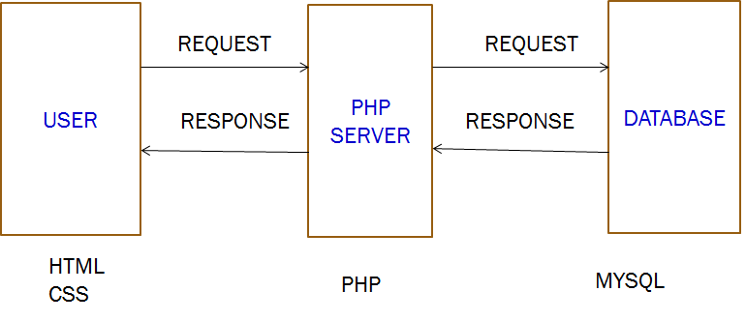

Fig: 4.1.1 PHP Development Diagram

**4.2 Data Flow Diagram**

**4.2.1 Context flow diagram**

User

Administrator

User ID, Complaints

Complaint Management

Solutions, Feedback

**Level 1 DFD- Administrator**

Add FIR Reports

Add mortem analysis

View Complaints

View user details

View Feedback

User name, Password

Administrator

User

Registration details

Complaints

Feedback

Add Solutions

FIR

Mortem Details

**Level 2 DFD- Administrator**

View Reports

Add Reports

FIR No: Details

FIR Details

Complaint Details

Complaints

FIR

Reports

Administrator

User

**Level 1 DFD- User**

Verify

Complaints

Username/Password

Registration

Login

Complaints

Username/Password

User

**Level 2 DFD- User**

Solutions

Complaint Details

Complaint Status

Complaint ID

User name Password

User

Complaint

Feedback

Complaint Status

**4.3 tables structure**

**4.3.1 Table Name: Login**

|  |  |  |  |
| --- | --- | --- | --- |
| **Fieldname** | **Data Type** | **Length** | **Key** |
| Username | Varchar | 20 | Primary key |
| Password | Varchar | 25 | - |
| login |  | 10 | - |

**4.3.2 Table Name: User Registration**

|  |  |  |  |
| --- | --- | --- | --- |
| **Fieldname** | **Data Type** | **Length** | **Key** |
| Name | Varchar | 20 | - |
| Occupation | Varchar | 20 | - |
| E-mail | Varchar | 20 | - |
| Age | Varchar | 50 | - |
| Aadhar No | Varchar | 50 | - |
| Mobile No | Varchar | 50 | - |
| Pincode | Integer | 9 | - |
| Address | Integer | 10 | - |
| State | Varchar | 30 | - |
| City | Varchar | 15 | - |
| Other personal details | Text | - | - |
| ID | Varchar | 15 | Primary key |

**4.3.3 Table Name: Crime Registration**

|  |  |  |  |
| --- | --- | --- | --- |
| Fieldname | Data Type | Length | Key |
| Name | Varchar | 20 | Primary key |
| Occupation | Varchar | 20 | - |
| Mobile No | Varchar | 20 | - |
| Age | Varchar | 50 | - |
| Address | Varchar | 50 | - |
| Aadhar No | Integer | 20 | - |
| State | Varchar | 20 | - |
| City | Varchar | 25 | - |
| Country | Integer | 11 | - |
| Pincode | Varchar | 25 | - |
| Location of incident | Varchar | 10 | - |
| People Involved | Integer | 10 | - |
| Nearest Police Station | Varchar | 30 | - |
| Date Of crime | Date |  |  |
| Describe the incident | Text | 400 | - |
| ID | Integer | - | Primary Key |

**4.3.4 Table Name: User Registration (WOMEN PORTAL)**

|  |  |  |  |
| --- | --- | --- | --- |
| **Fieldname** | **Data Type** | **Length** | **Key** |
| Name | Varchar | 20 | - |
| Occupation | Varchar | 20 | - |
| E-mail | Varchar | 20 | - |
| Age | Varchar | 50 | - |
| Aadhar No | Varchar | 50 | - |
| Mobile No | Varchar | 50 | - |
| Pincode | Integer | 9 | - |
| Address | Integer | 10 | - |
| State | Varchar | 30 | - |
| City | Varchar | 15 | - |
| Type of crime` | Varchar | 20 | - |
| People Involved | VARCHAR | 20 | - |
| Nearest Police Station | Varchar | 20 | - |
| Name of Accused | Varchar | 20 | - |
| Other personal details | Text | - | - |
| ID | Varchar | 15 | Primary key |
| Hide Details | Boolean | - | - |

**4.3.5 Table Name: Case Details**

|  |  |  |  |
| --- | --- | --- | --- |
| **Fieldname** | **Data Type** | **Length** | **Key** |
| Case No | Integer | 20 | Primary key |
| Name | Varchar | 25 | - |
| View Details |  | 10 | - |

**CHAPTER - 5**

**RESULT**

The project report entitled “E-COPS-Citizen Service” (ONLINE POLICE INVESTIGATORY SYSTEM) has come to its final stage. The system has been developed with much care that it is free of errors and at the same time it is efficient and less time consuming. The entire system is secured. The whole project is working on local host server. It is connected with database from where it access data and store data also.

The aim of proposed system is to develop a system of improved facilities. The proposed system can overcome all the limitations of the existing system. The system provides proper security and reduces the manual work. The existing system has several disadvantages and many more difficulties to work well. The proposed system tries to eliminate or reduce these difficulties up to some extent. The proposed system will help the user to reduce the workload and mental conflict. The proposed system helps the user to work user friendly and he can easily do his jobs without time lagging.

Various features are introduced in this project. The whole project is user friendly and easy to use; it is mainly developed for the ease of peoples or mankind to connect with our police and administrator department. Here they can easily find the solution of their problem.

* 1. **PROJECT SNAP SHOT:**

**(USER VIEW)**

1. Home Page:

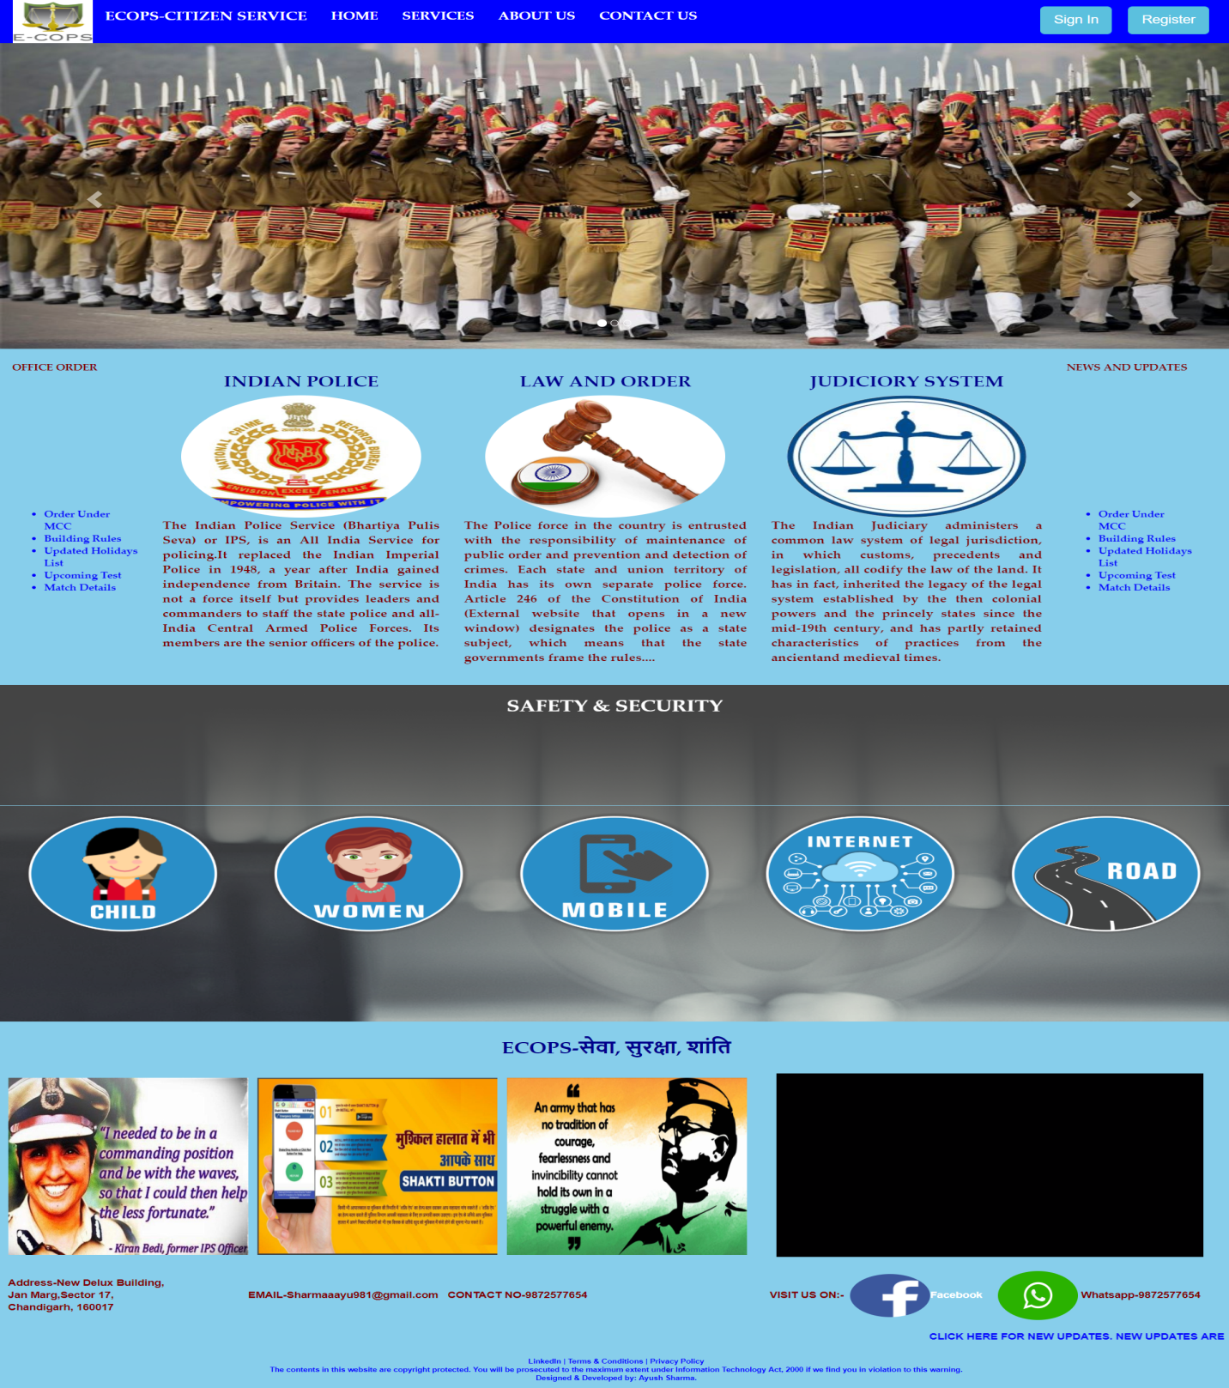

Fig: 5.1.1(A) Home Page

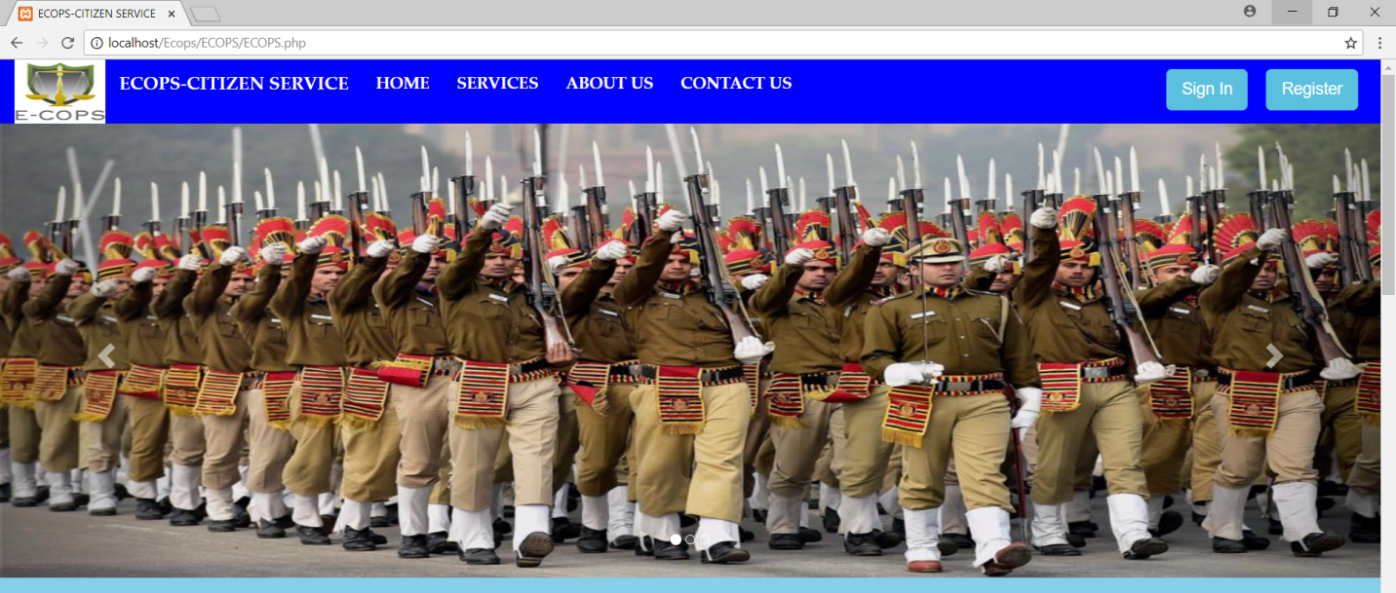

Fig: 5.1.1(B) Home Page

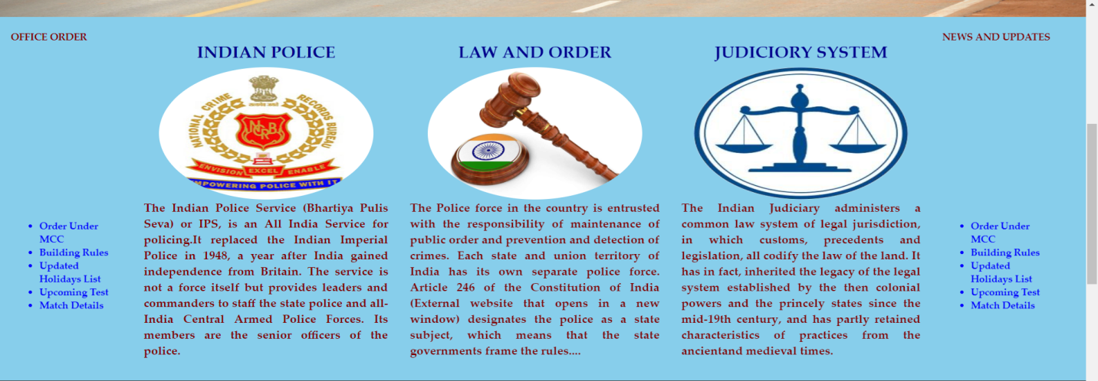

Fig: 5.1.1(c) Home Page

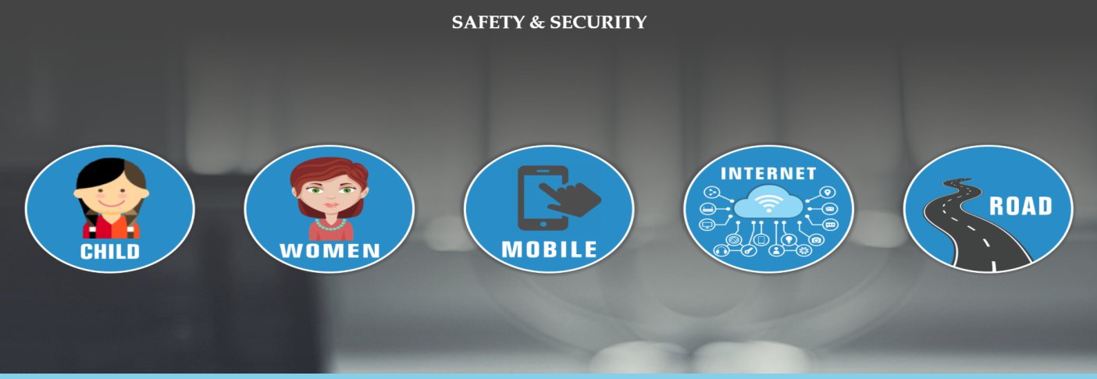

Fig: 5.1.1(d) Home Page



Fig: 5.1.1(e) Home Page

1. Image Gallery

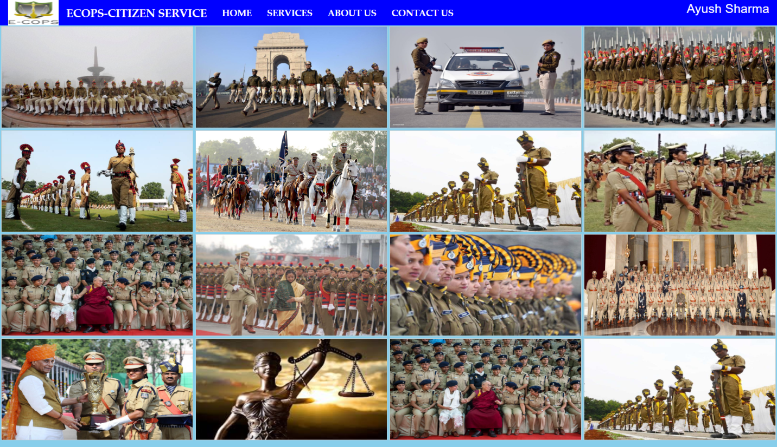

Fig: 5.1.2 Image Gallery

1. Achievements

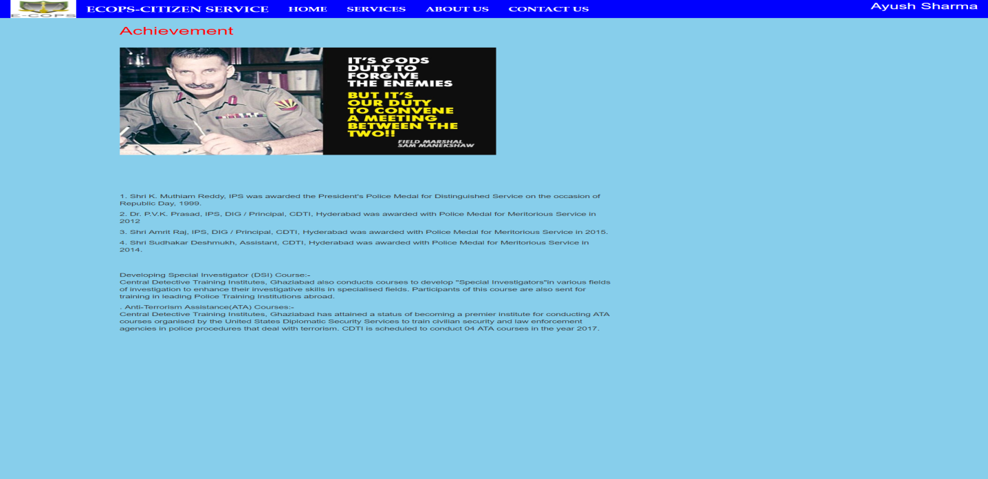

Fig: 5.1.3 Achievement

1. Self Defense Tips

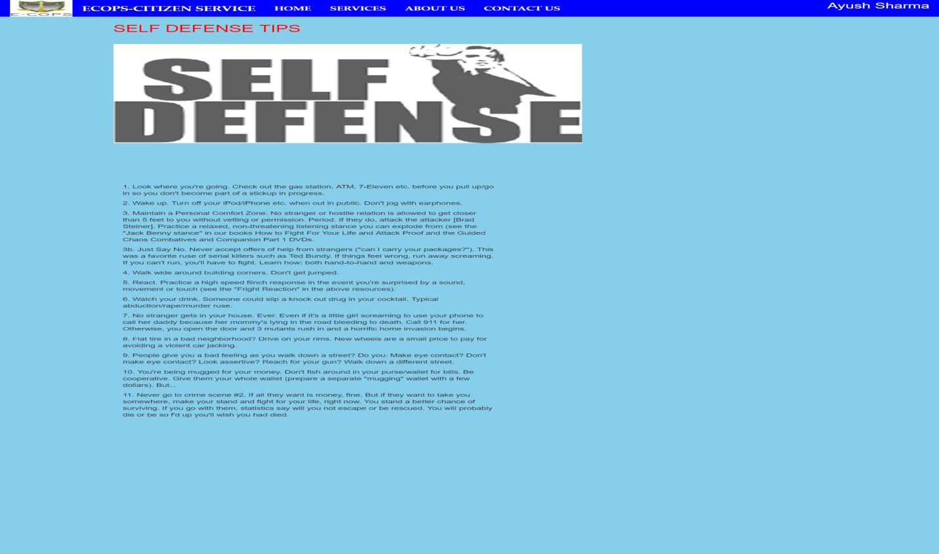

Fig: 5.1.4 Self Defense Tips

1. Important Numbers:

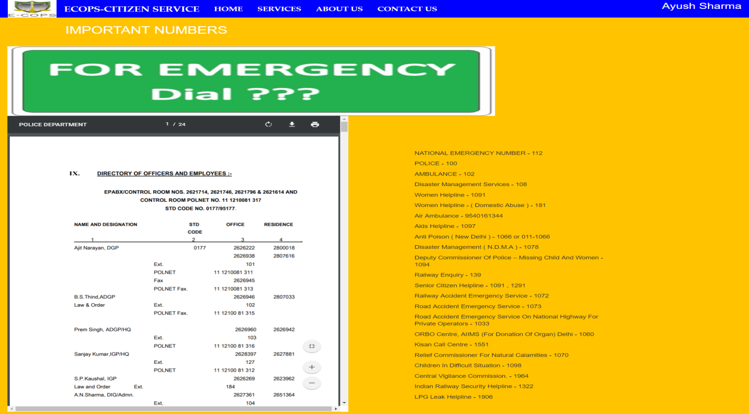

Fig: 5.1.5 Important Numbers

1. Police Stations

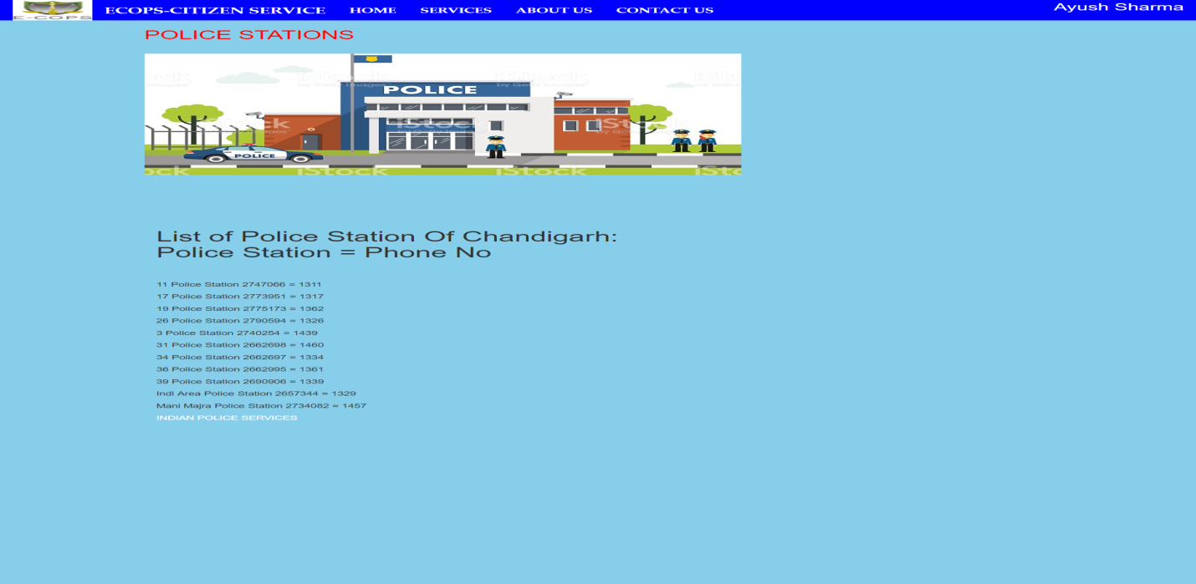

Fig: 5.1.6. Nearby Police Stations

1. Law & Order

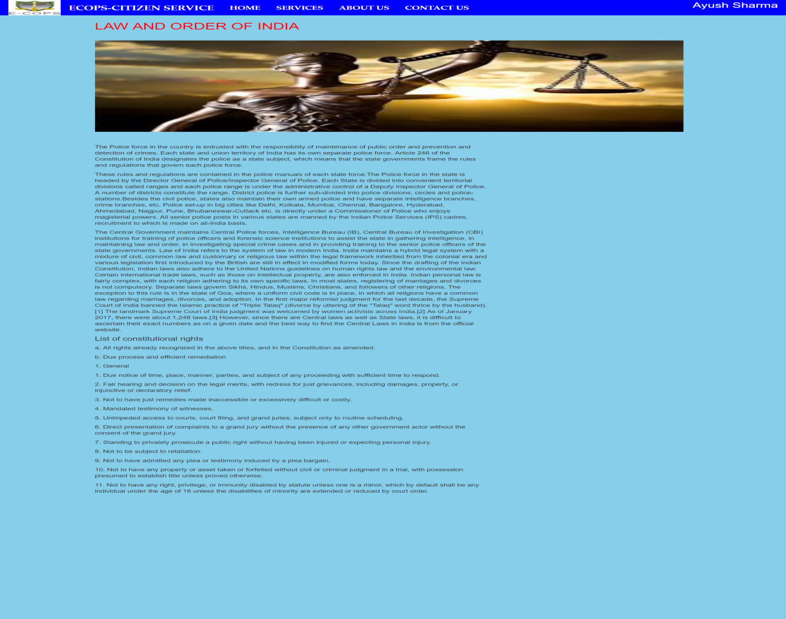

Fig: 5.1.7 Law & Order

1. SERVICES (Main Panel)

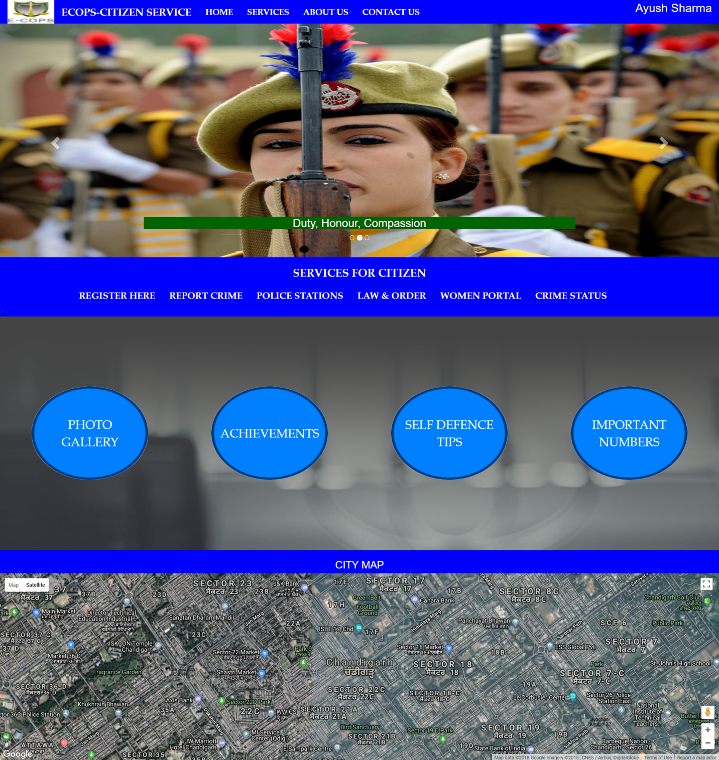

Fig: 5.1.8 SERVICES (Main Panel)

1. User Registration Form

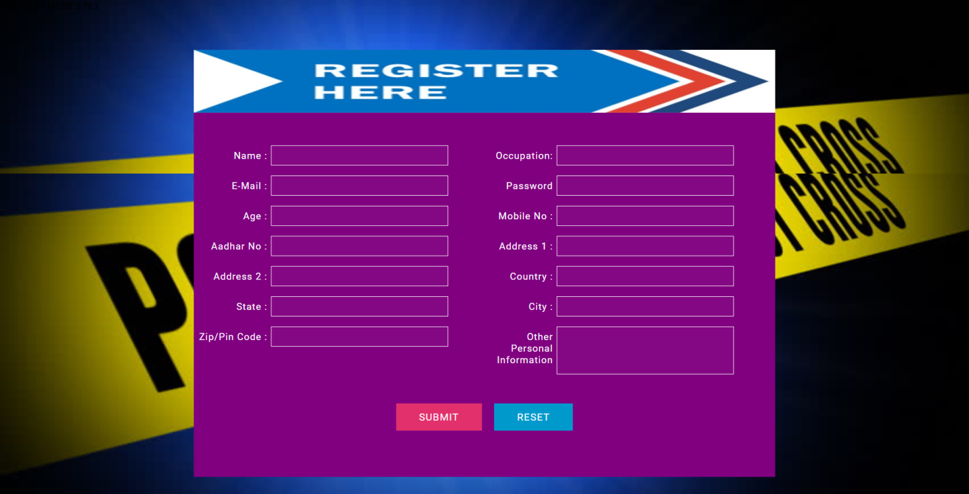

Fig: 5.1.9 User Registration Form

1. Crime Registration Form

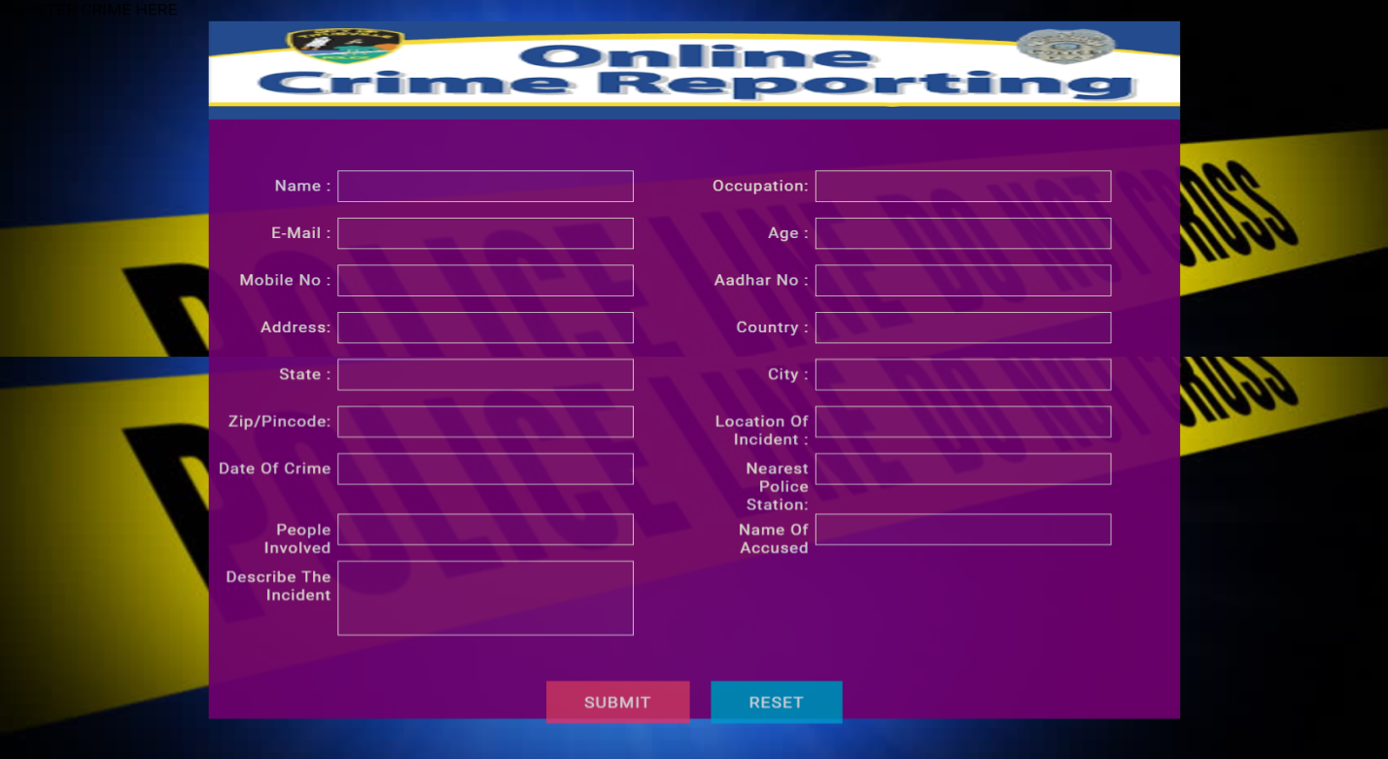

Fig: 5.1.10 Crime Registration Form

1. Women Complaint Registration Form:

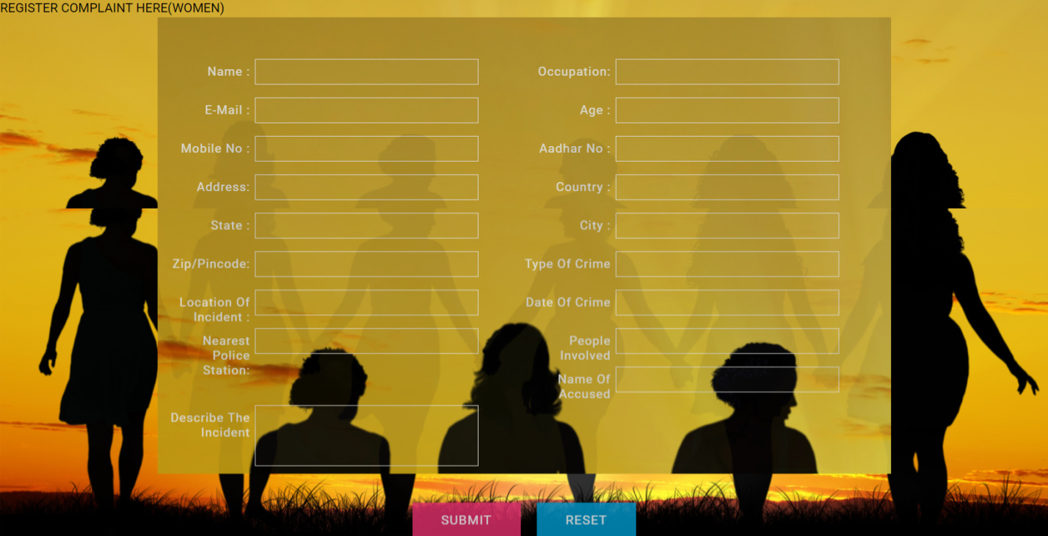

Fig: 5.1.11 Women Complaint Registration Form

1. Case Details

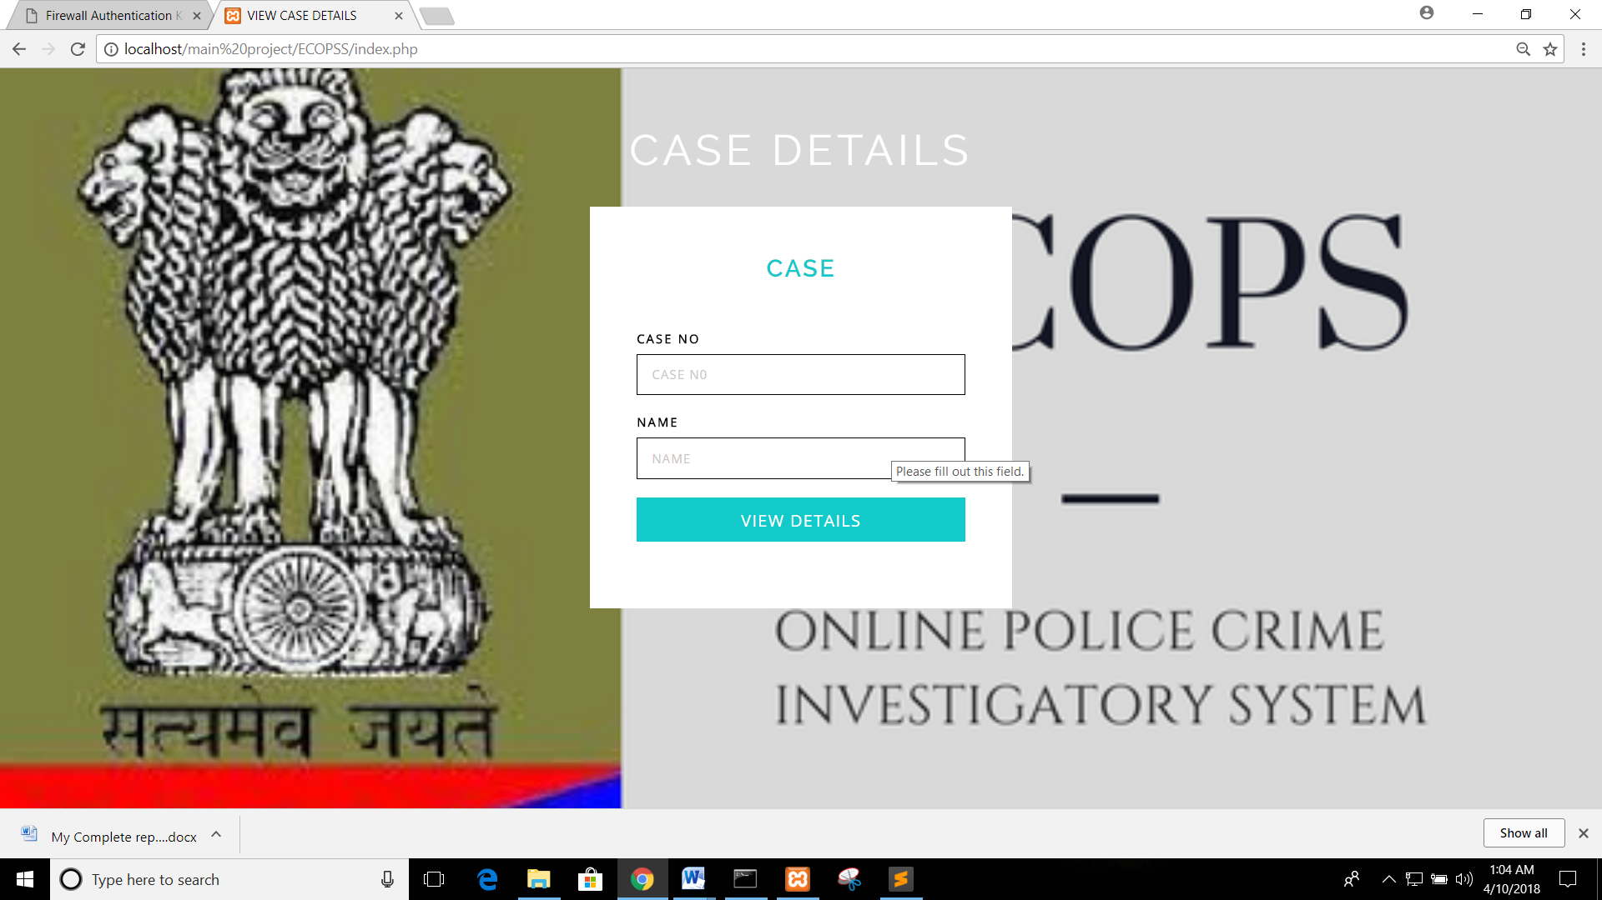

Fig: 5.1.12 Case Details

1. About US

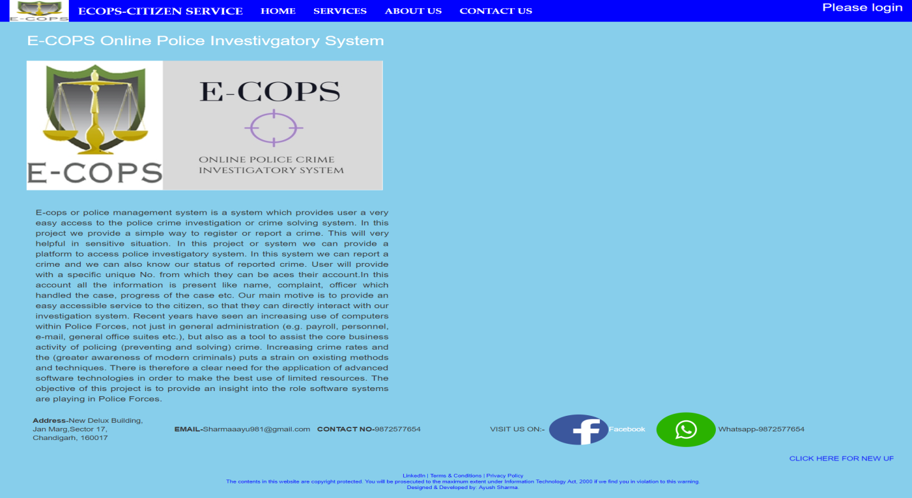

Fig: 5.1.13. About Us

1. Contact Us

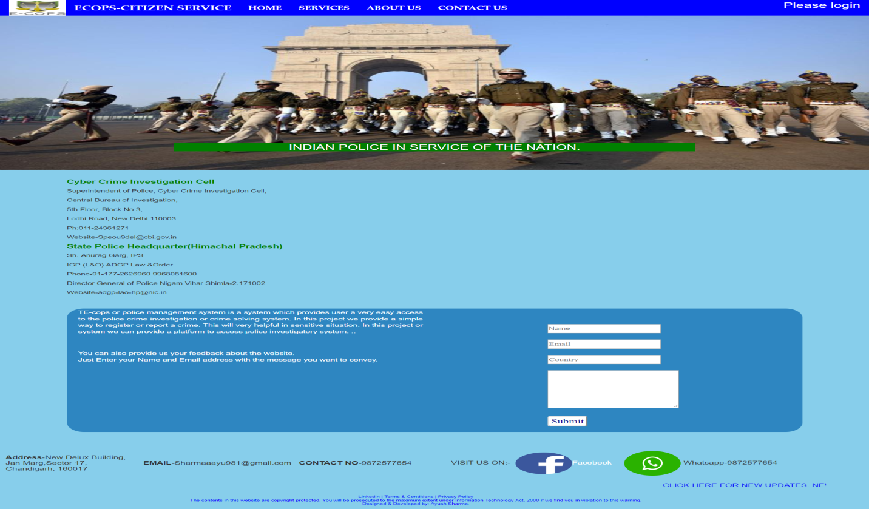

Fig: 5.1.14 Contact Us

1. Login Form

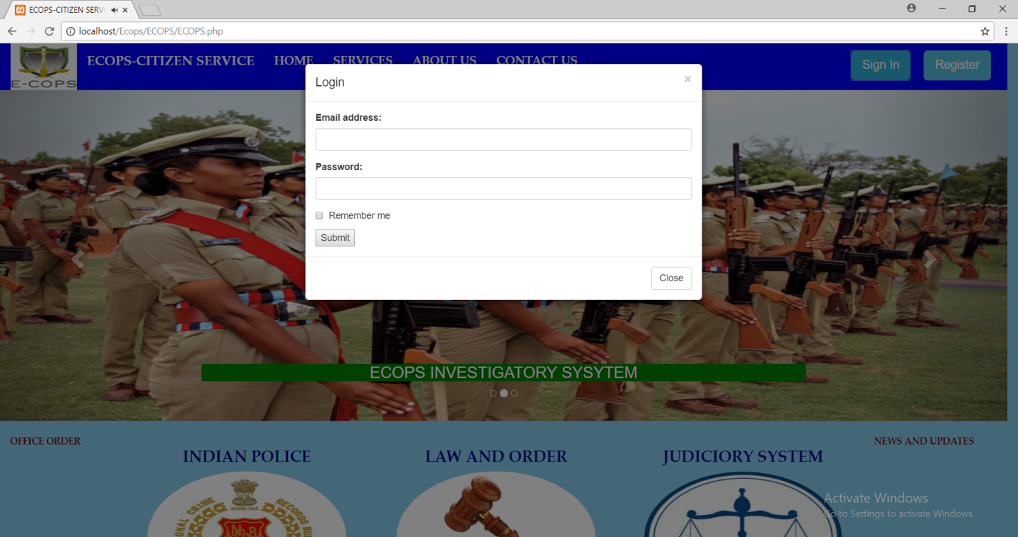

Fig: 5.1.15 Login Form

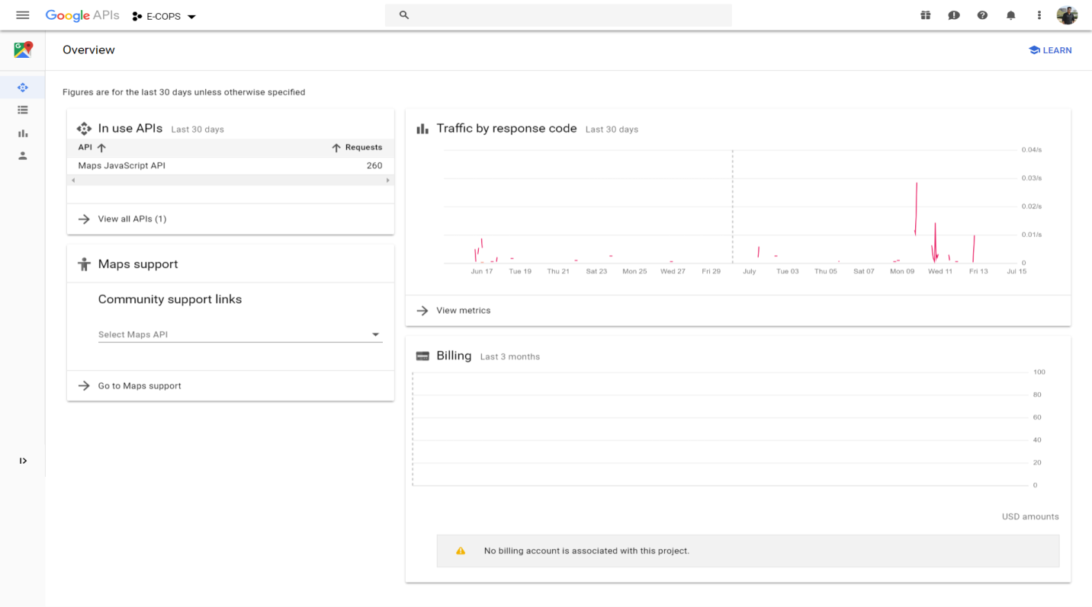

Fig: 5.1.16 Google Map API.(Traffic Graph)

**CHAPTER – 6**

**CONCLUSION**

The project titled as “E-COPS Citizen Service” Online Police Investigation System is a web based application. This application provides facility for reporting online crimes, complaints. This software is developed with scalability in mind. Additional modules can be easily added when necessary. The software is developed with modular approach. All modules in the system have been tested with valid data and invalid data and everything work successfully. Thus the system has fulfilled all the objectives identified and is able to replace the existing system.

The project has been completed successfully with the maximum satisfaction of the organization. The constraints are met and overcome successfully. The system is designed as like it was decided in the design phase. The project gives good idea on developing a full-fledged application satisfying the user requirements.

The system is very flexible and versatile. This software has a user-friendly screen that enables the user to use without any inconvenience. Validation checks induced have greatly reduced errors. Provisions have been made to upgrade the software. The application has been tested with live data and has provided a successful result. Hence the software has proved to work efficiently.

**6.1 SCOPE OF PROJECT**

Goals and scopes of the project are like:-

1. To provide easy way to interact with our law or police system.
2. User friendly interface for all.
3. Provide information about law and order.
4. Provide information about police stations nearby your location.
5. Provide a fast access and report a crime from any place.
6. Updated and maintained record of every case. (Gives Information about pending solved or under-processed cases).
7. Provide women a best level of security feature.
8. Special portal for women.(Hides the personal information of the women)
9. Special portal for police officers.(Login to their personal database; maintained by government
10. Further developed into android application (Which includes the GPS or Current location service).
11. Ensure data accuracy’s.
12. Proper control of the higher officials.
13. Reduce the damages of the machines.
14. Minimize manual data entry.
15. Minimum time needed for the various processing.
16. Greater efficiency.
17. Better service.
18. User friendliness and interactive.
19. Minimum time required.

**CHAPTER - 7**

**REFRENCES**

[1]. <https://en.wikipedia.org/wiki/HTML>

[2]. <https://www.tutorialspoint.com/php/index.htm>

[3]. <https://ips.gov.in/>

[4]. <https://en.wikipedia.org/wiki/Indian_Police_Service>

[5]. <https://www.w3schools.com/css/>

[6]. PHP and MYSQL web development by Luke Welling